Methocel Delivery System

Adriaan Riet

Sean Lawry

Austin Smith

October 7, 2014

Table of Contents

Abstract 2

Introduction 2

Apparatus Design 2

Experimental Procedure 3

Safety 3

Theory and Data 4

Results 5

Data Analysis 6

Sources of Error 7

Conclusions & Recommendations 7

Appendix A 7

Acknowledgement 8

References 8

## 

## Abstract

Methocel, a non-Newtonian fluid, is to be pumped from a railway terminal to a nearby plant. A delivery system is already in place, but must be adequate to transport the fluid without exceeding the rupture disk pressure rating (250 psig). An apparatus has been constructed to measures the flow rate and pressure drop of methocel. This apparatus yielded rheological data whichwas used to determine the adequacy of the transport system. Based on the data, a pressure drop of 81 psi was calculated, which is well below the 250 psig pressure rating.

## Introduction

Methocel must be transported to a new plant from the nearby railway terminal. A delivery system is already in place, and the team’s objective is to determine if it can transport 75 gallons per minute of a 1% (by weight) methocel solution without exceeding the rupture disk pressure rating (250 psig). The company lab contains a system designed to measure flow rate and pressure drop of the methocel solution in two different pipe sizes. The test system can be used to determine the rheology of the fluid, which can be used to determine the pressure drop in the system in place. Methocel is a known non-Newtonian fluid and cannot be modeled like most liquids. DOW Chemical lists methocel as a pseudo-plastic fluid that follows the power law model [Source 1]. This model and the data from the apparatus can be been used to determine the rheological parameters n and K (discussed below) of methocel, as well as the pressure drop in the pipe. The pressure drop through the pipe represents the minimum required pressure at the existing transport system. If the minimum pressure exceeds the rupture disk rating, a new transport system will be designed. The team was also assigned to compare the behavior of methocel solution vs. water.

## Apparatus Design

A large tank with two mixers keeps the 1% methocel solution well-mixed. A computer controlled valve maintains a constant flow rate, and a second valve switches between the two pipe sizes. Each of these copper pipes has a pressure transducer that measures pressure drop as a function of distance. The pressure drop and flow rate data is then transmitted to a computer. The computer is set to provide one measurement per second for 100 seconds. Figure 1 diagrams the apparatus.

## schematic.pngExperimental Procedure

The experiment was performed in two pipes of different diameters, at ten different flow rates in each pipe. Performing the experiment in two separate pipe sizes allowed for two separate experiments, which could be compared to determine the validity of the data. Each flow rate contains 100 measurements taken at one-second intervals. Randomized experiments minimized any systematic disturbances. Measured variables included the pressure drop across the active pipe, flow rate, time the reading was taken, pressure drop across the inactive pipe, ambient temperature, ambient pressure, flow setpoint and the valve controller output.

*Figure 1*

## Safety

The equipment of the experiment posed potential hazards. There were mixers mixing the solution throughout the lab period. A pump was used to transport the fluid. One of the team members was always observing the tank while the system was running. This was to ensure others would not come into contact with any of the equipment. The pump was turned off as soon as the data collection was completed. The valve that changed the flow from the large to small diameter pipe had to be switched when the pump was off. Because fluids were involved in this experiment, care was taken to minimize any potential electrical hazard. Methocel in solution is not particularly hazardous, but is flammable as a powder. The flammability hazard was low since the experimental material involved methocel in solution.

## Theory and Data

It is assumed that methocel is a power law fluid. According to David Lignell’s notes [Source 2], if a fluid follows the power law it will obey equation 1:

|  |  |  |
| --- | --- | --- |
|  | $τ={K(-\frac{dv}{dr})}^{n}$ | (1) |

where $τ$ is shear stress, $K$ and $n$ are empirically determined constants, and $\frac{dv}{dr}$ is a change in velocity per change in radial distance. $τ$ is calculated using equation 2.

|  |  |  |
| --- | --- | --- |
|  | $$τ= -\frac{R}{2}\frac{dP}{dx}$$ | (2) |

which requires the pressure drop (*dP/dx*) and pipe radius (R), both of which are specified. In order to determine $n$ and $K$, equation 3 may be used. Equations 4, 5, and 6 have been defined for simplicity.

|  |  |  |  |  |
| --- | --- | --- | --- | --- |
|  | $$\ln{(τ})=n\ln{(v})+\{\ln{(K})+n\ln{(\frac{2(3n+1)}{nD}})\}$$ | | | (3) |
|  | | $$Ω=n ln(\frac{2\left(3n+1\right)}{nD})$$ | (4) | |
|  | | $$δ=ln(τ)$$ | (5) | |
|  | | $$Θ=ln(v)$$ | (6) | |

By fitting the natural logarithm of shear stress and velocity to a line, $n$ and $K$ were determined. Equation 7 models pressure drop due to friction in a circular pipe.

|  |  |  |
| --- | --- | --- |
|  | $$ΔP=\frac{-fLv^{2}}{2D}$$ | (7) |

where P is pressure, f is the Darcy friction factor, L is the length of the pipe, v is average velocity through the pipe, and D is the inner diameter of the pipe.

$f$ was found using a modified Reynolds number, given by equation 8.

|  |  |  |
| --- | --- | --- |
|  | $$Re=\frac{8ρv^{2}}{K}(\frac{nD}{2(3n+1)v})^{n}$$ | (8) |

and using a Non-Newtonian Moody chart [Source 2].

In a system using water, the Reynolds number and friction factor would be given by equations 9 and 10 [Source 4].

|  |  |  |
| --- | --- | --- |
|  | $$Re=\frac{ρvD}{μ},$$ | (9) |

|  |  |  |
| --- | --- | --- |
|  | (turbulent). | (10) |

Once $f$ was acquired, an estimate of the pressure drop was obtained with the above relations.

## Results

The current pipeline in place is suitable to transport methocel from the railway to the plant. The pressure drop calculated through experimentation is 81.4 psig and this is less than the maximum pressure of 250 psg. The pressure drop of water running through the same piping system was calculated at 26 psig.  The flow behavior index (n) determines the type of fluid. Newtonian fluids are n=1, pseudo-plastic fluids n<1, and Bingham plastics n>1. The fluids act differently under shear stress. Pseudo-plastic fluids experience a decrease in viscosity under increasing shear stress, Bingham plastics get thicker under a higher shear stress. The calculated flow behavior index of 1% methocel was determined to be 0.64. Because n is well below 1, the results show conclusively that methocel is a pseudo- plastic fluid.

|  |  |  |  |  |  |  |
| --- | --- | --- | --- | --- | --- | --- |
|  | n | K | Re | f | dP (Pascals) | dP (psi) |
| small pipe | 0.59 | 1.21 | 950 | 0.07 | 5.61E+05 | 81.3 |
| large pipe | 0.70 | 0.69 | 896 | 0.07 | 5.94E+05 | 86.2 |
| weighted average | 0.64 | 0.89 | 949 | 0.07 | 5.61E+05 | 81.4 |

## Data Analysis

Measurements from each pipe were grouped together. For every data point taken, pressure drop per length of pipe was calculated from the measured pressure drop and the measured distance between the pressure sensing probes. To determine pipe diameter, the pipe circumference was measured and converted to an outside diameter, or a nominal pipe diameter was read from the pipe. This was referenced with literature to obtain the inner diameter of the pipe (which is the diameter used in all referenced equations) [3]. For each data point, an average fluid velocity was calculated from the measured flow rate and the inner pipe diameter. Shear stress was calculated using equation (2) and the calculated pressure drop per length of pipe. With this information, ln(τ) [ln(shear stress)] and ln(v) [ln(velocity)] were calculated.

Linear regressions were performed on ln(τ) and ln(v) (in the form of equation (3)). The slope of the regressed line was taken to be a measured value of n. The measured value of n was used to calculate Ω (defined in equation 4). The exponential of the difference between the intercept and Ω was taken to be a measurement of K. In this manner, K and n values were generated for both pipes. For convenience, equation 4 is repeated here.

|  |  |  |
| --- | --- | --- |
|  | $$Ω=n\ln\left(\frac{2\left(3n+1\right)}{nD}\right)$$ | (4) |

|  |  |  |  |
| --- | --- | --- | --- |
|  |  |  |  |
|  |  |  | Ω |

Another linear regression was performed to reconcile the data on the assumption that the true n and K values were the same for the fluid in both pipes (which should be true for a power law fluid.) In order to do this, a linear regression of ln(τ) - Ω versus ln(v) was used instead of the original in order to use all of the data as a whole.

|  |  |  |  |
| --- | --- | --- | --- |
| $$y$$ | $$m$$ | $$x$$ | $$b$$ |
| $ln\left(τ\right)-Ω$ | $$n$$ | $$ln(v)$$ | $$ln\left(K\right)$$ |

To obtain Ω, the pipe diameter corresponding to each data point was used, and n was calculated iteratively. Residuals were plotted as well. 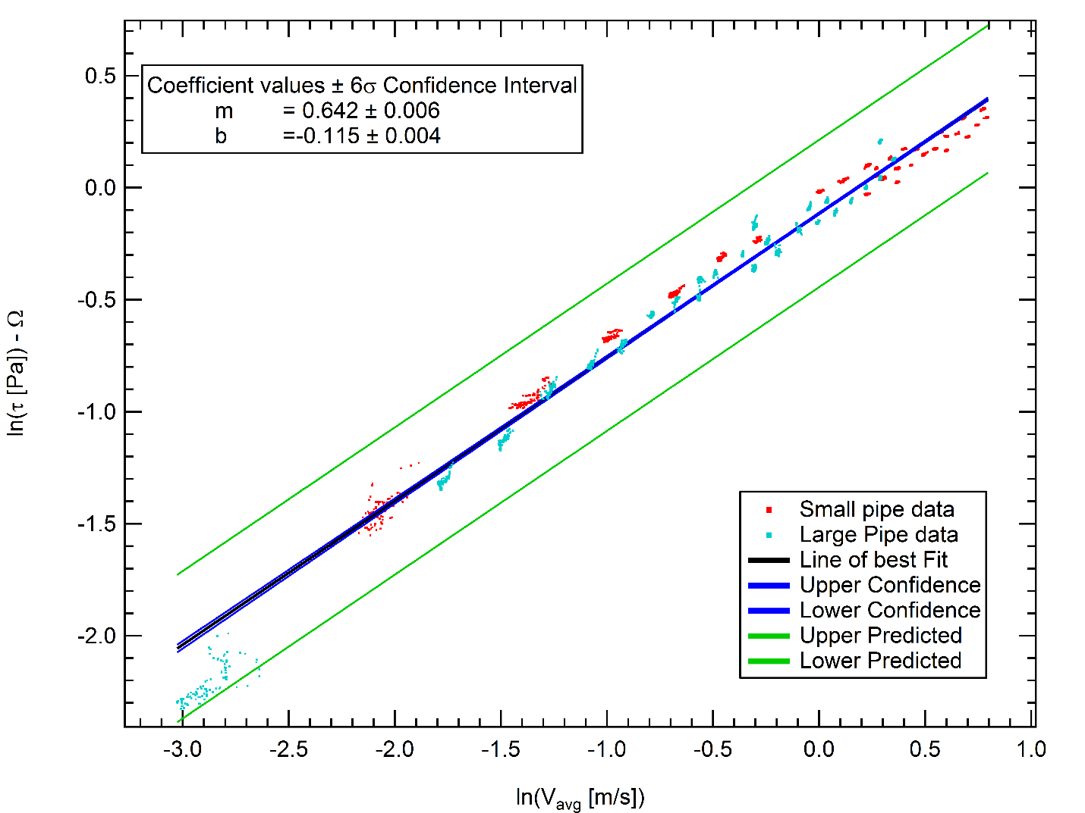

There was some initial concern about the cluster of data in the bottom left of both plots. These points correspond to very low flow rates in the large pipe. The data was taken to ensure that the pressure/shear relation went to zero in the limit of no flow, and was taken at a much lower flow rate than the rest of the data. Errors here are magnified due to the nature of logarithms. The Reynolds numbers were also calculated once values of n and K were known. The Reynolds numbers for various flows in the small pipe ranged between 280 and 920, while the large pipe had Reynolds numbers between 115 and 400.

## Sources of Error

The data taken showed high levels of confidence in the measured results. The experiment however did have some sources of error. The main sources of error come from the measurement devices used. One pressure transducer was measuring a slight pressure drop even without flow. Also the smaller pipe was slightly bowed, due to a table being pushed up against it. The flow rate being controlled by the valve also was not perfectly constant. This could add some error to the calculations. There are also possible errors due to the pipes having a different roughness. These each should be small, but contribute to the error that was seen in the results.

## Conclusions & Recommendations

The pipeline in place can transport methocel to the plant. The pressure drop of methocel in the current piping system is 81.4 psig, while the system can maintain up to 250psig. The data had a high level of confidence as shown in figure 2. Methocel had a measured n value of 0.64 which determines that it is a pseudo-plastic fluid. Methocel is expected to run through the pipe with about three times the pressure drop as water would. This reaches the specifications of the existing pipeline and no new pipeline system is necessary.

The projected Reynolds number for the existing system at the specified flow rate (75 gpm) would be about 950. It would be better to operate the test at Reynolds numbers around the Reynolds number of the system, but the pump in the test apparatus is unable to push flow rates high enough to do that in either pipe. This is unfortunate, but not catastrophic, as the flow is still projected to be laminar (nonlinearities due to turbulent flow should tend to decrease shear since the fluid is pseudoplastic).

## 

## Appendix A

|  |  |
| --- | --- |
| D | Pipe inner diameter |
| f | Friction factor |
| K | Non-Newtonian experimental constant |
| L | Length of installed pipe |
| n | Non-Newtonian experimental constant |
| P | Pressure |
| R | Pipe inner radius |
| ρ | Density |
| Re | Reynold’s number |
| τ | Shear stress |
| v | Average velocity |
| x | Position of pressure transducer |
| v | Viscosity |
| Ω | Defined in equation 4 |

## Acknowledgement

We would like to acknowledge Troy Holland for his assistance in improving this paper.

We would like to acknowledge Colton Hickman for his excellent critique of this paper.

## 

## References

1. Dow Chemical Company. “METHOCEL Cellulose Ethers.” *Technical Handbook*. Sept. 2012: 16.
2. Lignel, David. “NonNewtonian Fluids.” Fluid Mechanics Lecture. Provo, UT
3. “Copper Tubes – ASTM B88.” <engineeringtoolbox.com>. Accessed Sept. 2014.\
4. Engel, Yunus A., and John M. Cimbala. *Fluid Mechanics: Fundamentals and Applications*. Third ed. 2014. Print.